Sabbath Message
January 10, 2026
Welcome & Prayer
John 1:1 In the beginning was the Word, and the Word was with God, and the Word was God.

Beginning 746, ar-khay’; from 756; (properly abstract) a commencement, or (concrete) chief (in various applications of order, time, place or rank): -beginning, corner, (at they, the) first (estate), magistrate, power, principality, principle, rule.

Word, 3056, logo, log’-os; from 3004; something said (including the thought);

God spoke the earth into existence in Genesis 1:6, 9, 11, 14, 20, 24, 26, and 29

Jesus Christ is the Word.

John 1:2 The same was in the beginning with God.

Genesis 1:1 In the beginning God created the heaven and the earth.

John 1:3 All things were made by him; and without him was not any thing made that was made.

Genesis 1:31 And God saw every thing that he had made, and, behold, it was very good. And the evening and the morning were the sixth day.

John 1:4 In him was life; and the life was the light of men.

Greek Life 2222 dzo-ay’ from 2198; life (literal or figurative): -life

Greek light 5457 foce; from an obsolete phao, luminous: fire light.

Genesis 1:3 And God said, Let there be light: and there was light.

Genesis 2:7 And the LORD God formed man of the dust of the ground, and breathed into his nostrils the breath of life; and man became a living soul.

Psalms 33:6 By the word of the LORD were the heavens made; and all the host of them by the breath of his mouth.

John 1:5 And the light shineth in darkness; and the darkness comprehended it not.

Genesis 1:2 And the earth was without form, and void; and darkness was upon the face of the deep. And the Spirit of God moved upon the face of the waters.
Genesis 1:3 And God said, Let there be light: and there was light.

Genesis 1:4 And God saw the light, that it was good: and God divided the light from the darkness.

Darkness was already present, God spoke light into existence
God created man and women in Genesis 1: 26And God said, Let us make man in our image, after our likeness: and let them have dominion over the fish of the sea, and over the fowl of the air, and over the cattle, and over all the earth, and over every creeping thing that creepeth upon the earth.

Genesis 1: 27So God created man in his own image, in the image of God created he him; male and female created he them.

But then in Genesis 2:7 And the LORD God formed man of the dust of the ground, and breathed into his nostrils the breath of life; and man became a living soul.

Jesus Yashua did many miracles when He walked in the flesh. Healing the sick and lame, making the blind to see, deaf to hear. He even raised the dead back to life. Yet is there documentation of Jesus doing the type of creation mentioned in Genesis 2:7? The earliest written record of Yashua’s, Jesus, childhood has been recently transcribed.
A recently deciphered manuscript, dating back to the 4th or 5th century and stored in a university library in Hamburg, Germany, has been identified by researchers as the earliest surviving account of Jesus Christ's childhood.
While the words in the document are not from the Bible, they describe a "miracle," according to the Gospel of Thomas, that Jesus performed as a 5-year-old child as he moulded soft clay from a river into sparrows and then brought them to life.

(It goes on to say later)

The small fragment, which measures just over 4 inches by 2 inches, contains thirteen lines of Greek letters from late antique Egypt. (See story below)

Was Jesus in Egypt?

In Matthew 2:13 And when they were departed, behold, the angel of the Lord appeareth to Joseph in a dream, saying, Arise, and take the young child and his mother, and flee into Egypt, and be thou there until I bring thee word: for Herod will seek the young child to destroy him.
Herod lived from 73 BCE to 4 BCE making the timeline for this event to be possible to have happened in Egypt. (See Herod below)
Matthew 2:19But when Herod was dead, behold, an angel of the Lord appeareth in a dream to Joseph in Egypt,

Matthew 2:20Saying, Arise, and take the young child and his mother, and go into the land of Israel: for they are dead which sought the young child's life.

Matthew 2:21And he arose, and took the young child and his mother, and came into the land of Israel.

Yashua did many miracles and even as a child had the power of God to create for the good of man. He gave His all for you, can you give a little of you to Love Him, obey Him, study His word?

Reference

1,600-year-old fragment identified as oldest written account of Jesus Christ's childhood
Sheri Walsh
Updated Thu, June 13, 2024 at 5:23 AM MDT
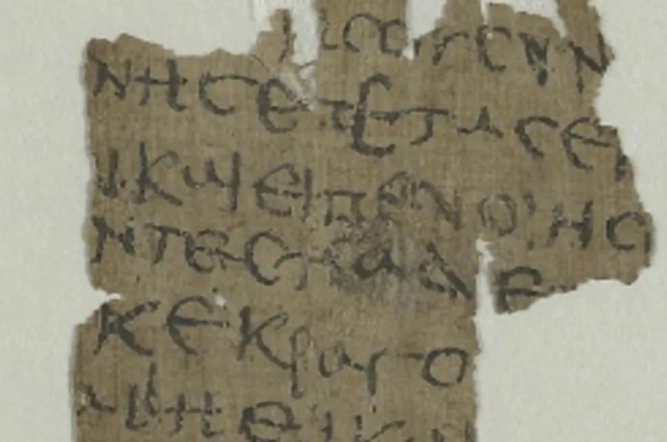
A papyrus fragment, dating from the 4th to 5th century, was recently deciphered after being stored for decades in a university library in Hamburg, Germany. It has been identified by researchers as the earliest surviving writings about Jesus Christ's childhood. Photo courtesy of Staats- und Universitätsbibliothek Hamburg/Public Domain Mark 1.0
June 12 (UPI) — A recently deciphered manuscript, dating back to the 4th or 5th century and stored in a university library in Hamburg, Germany, has been identified by researchers as the earliest surviving account of Jesus Christ's childhood.
"Our findings on this late antique Greek copy of the work confirm the current assessment that the 'Infancy Gospel of Thomas' was originally written in Greek," said papyrologist Gabriel Nocchi Macedo from the University of Liège in Belgium.
The papyrus fragment, dating back more than 1,600 years, had gone unnoticed for decades at the Hamburg Carl von Ossietzky State and University Library, until Macedo and Dr. Lajos Berkes from the Institute for Christianity and Antiquity at Humboldt-Universität zu Berlin identified its true origin.
The small fragment, which measures just over 4 inches by 2 inches, contains thirteen lines of Greek letters from late antique Egypt. The content was originally thought to be part of "an everyday document, such as a private letter or a shopping list, because the handwriting is so clumsy," said Berkes. "Then, by comparing it with numerous other digitized papyri, we deciphered it letter by letter and quickly realized it could not be an everyday document."
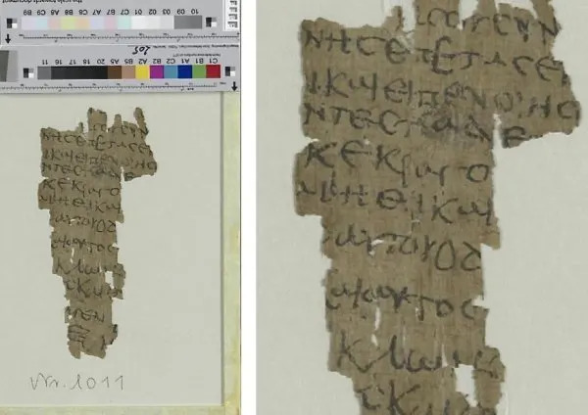

The researchers believe the copy of the Gospel was created as a writing exercise — given the clumsy handwriting and irregular lines — in a school or monastery, which would make it a much earlier surviving copy of the gospel than the 'Infancy Gospel of Thomas' manuscript from the 11th century.
"The fragment is of extraordinary interest for research," said Berkes. "On the one hand, because we were able to date it to the 4th to 5th century, making it the earliest known copy. On the other hand, because we were able to gain new insights into the transmission of the text."
While the words in the document are not from the Bible, they describe a "miracle," according to the Gospel of Thomas, that Jesus performed as a 5-year-old child as he moulded soft clay from a river into sparrows and then brought them to life.
Retrieved June 13, 2024 from 1,600-year-old fragment identified as oldest written account of Jesus Christ's childhood (yahoo.com)

Herod
king of Judaea
Herod (born 73 bce—died March/April, 4 bce, Jericho, Judaea) was the Roman-appointed king of Judaea (37–4 bce), who built many fortresses, aqueducts, theaters, and other public buildings and generally raised the prosperity of his land but who was the center of political and family intrigues in his later years. The New Testament portrays him as a tyrant, into whose kingdom Jesus of Nazareth was born.
Retrieved January 8, 2026 from Herod | Biography, Facts, Reign, Temple, & Jesus | Britannica

