Signs of Christ’s Return
October 3, 2026

Retrieved September 28, 2026, from 12 Signs of Christ’s Return - Carl Joseph Ministries

“Knowing this first, that there shall come in the last days scoffers, walking after their own lusts, and saying, where is the promise of his coming? for since the fathers fell asleep, all things continue as they were from the beginning of the creation.”
2nd Peter 3:3-4

1. The rapid increase in knowledge (Daniel 12:4)
In the 1980’s Buckminster Fuller created the “Knowledge Doubling Curve.” Until the early part of the 20th century, knowledge doubled every 25 years or so. But currently, knowledge is doubling every 13 months, and according to IBM that could become every 12 hours in the not-too-distant future. Google enables us to capture millions of threads of data at our fingertips. The prophet Daniel spoke of this knowledge increase which would reach its climax at the end of time:

2. The rise of false cults (Matthew 24:5)
In Christ’s Olivet Discourse (Matt 24-25, Luk 21, Mk 13), He offers several clear markers for His return, with deception being first on the list. So far there have been at least 22 notable false Christ’s since the 18th century, spanning from Ann Lee to Alan John Miller of the present day. The Russian leader, Sergey Anatolyevitch Torop, has publicly claimed to be the risen Christ, since 1991 and currently has 5,000 followers worldwide. Brazilian born Alvaro Theiss, has also claimed to be Jesus Christ for more than 30 years, and enjoys a wide following.

3. Many shall go to and fro (Daniel 12:4)
Up until the late 19th century, the light two-person horse and buggy was the main mode of transport. In 1885 the first car was invented by Karl Benz. In 2020, there were 287 million cars in the United States alone. The minor prophet Nahum, prophesied the modern-day freeway, stating:

“The chariots shall rage in the streets, they shall justle one against another in the broad ways: They shall seem like torches, They shall run like the lightnings.”
Nahum 2:4

4. The sign of the fig tree (Matthew 24:32)
The main sign of Christ’s return is the formation of Israel as a nation. Israel is symbolized as a fig tree in the books of Jeremiah, Habakkuk, Joel and Hosea. Following their rejection of His son, God promised to restore Israel as a nation with an outstretched arm and gather them out of the countries into which they were scattered (Eze 20:33-24). This was fulfilled, by the fig tree blossoming on May 14th, 1948. Jesus said, the same generation that sees this fig tree blossom will also see His return (Matt 24:32).

9. The return of the days of Noah (Luke 17:26)
Although the ‘days of Noah’ resulted in the destruction of the human race, save Noah and his family, there are some stark aspects of that time frame which have been overlooked. The days of Noah were clearly marked by moral degradation and increased violence, in tandem with rising population, to the point where God saw the wickedness of man, and every imagination of his heart being evil, continually. As a consequence, God was grieved and regretted He ever made man (Gen 6:5). However, the ‘evil’ spoken of in this passage, also included an incursion of Watcher angels, outlined in Genesis 6:1-4. This is also well documented in historical texts such as, the Book of Enoch, the Book of Jasher, the Book of Giants and Book of Jubilees.

10. Great and fearful sights and great signs in the heavens (Luke 21:11)
Has anyone seen a UFO lately? Sightings of UFO’s are definitely on the increase and these visitors will soon become part of a global deception. UFO’s (or UAP’s -Unidentified Arial Phenomenon), will play a major part in the end-time deception of mankind. When the church is removed from the earth, the ‘restrainer’ will no longer be able to hold back Satan’s deceptive agenda (2 Thess 2:6-7). As L.A. Marzulli likes to say, ‘when we go up, they show up!” I firmly believe that aliens will claim to be progenitors of the human race and spin the evacuation of the church for their own advantage. The notion that aliens spawned life on earth is known as ‘Panspermia.’ UFO’s have been appearing in the skies from the beginning of time because the second heaven is Satan’s domain (Eph 2:2). Full disclosure of UFO’s have even been promised by our government in recent years, with military personnel sharing their encounters on news networks. Something is afoot.

12 Signs of Christ’s Return
by Carl JosephJune 26, 2022

1. The rapid increase in knowledge (Daniel 12:4)
In the 1980’s Buckminster Fuller created the “Knowledge Doubling Curve.” Until the early part of the 20th century, knowledge doubled every 25 years or so. But currently, knowledge is doubling every 13 months, and according to IBM that could become every 12 hours in the not-too-distant future. Google enables us to capture millions of threads of data at our fingertips. The prophet Daniel spoke of this knowledge increase which would reach its climax at the end of time:

“Knowing this first, that there shall come in the last days scoffers, walking after their own lusts, and saying, where is the promise of his coming? for since the fathers fell asleep, all things continue as they were from the beginning of the creation.”
2nd Peter 3:3-4
”But thou, O Daniel, shut up the words, and seal the book, even to the time of
The ‘time of the end,’ spoken of by the angel in this passage refers to today, i.e., ‘the last days.” Our time is reserved for not only a general knowledge explosion, but more precisely, knowledge of God’s word. I dare say this seal was cracked at the beginning of the 20th century. It’s for the ‘wise’ to understand the signs of the times, and the wicked will remain ignorant of what’s going on around them, right up until Christ’s coming.
The knowledge of ‘all things’ is increasing rapidly

2. The rise of false cults (Matthew 24:5)
In Christ’s Olivet Discourse (Matt 24-25, Luk 21, Mk 13), He offers several clear markers for His return, with deception being first on the list. So far there have been at least 22 notable false Christ’s since the 18th century, spanning from Ann Lee to Alan John Miller of the present day. The Russian leader, Sergey Anatolyevitch Torop, has publicly claimed to be the risen Christ, since 1991 and currently has 5,000 followers worldwide. Brazilian born Alvaro Theiss, has also claimed to be Jesus Christ for more than 30 years, and enjoys a wide following.
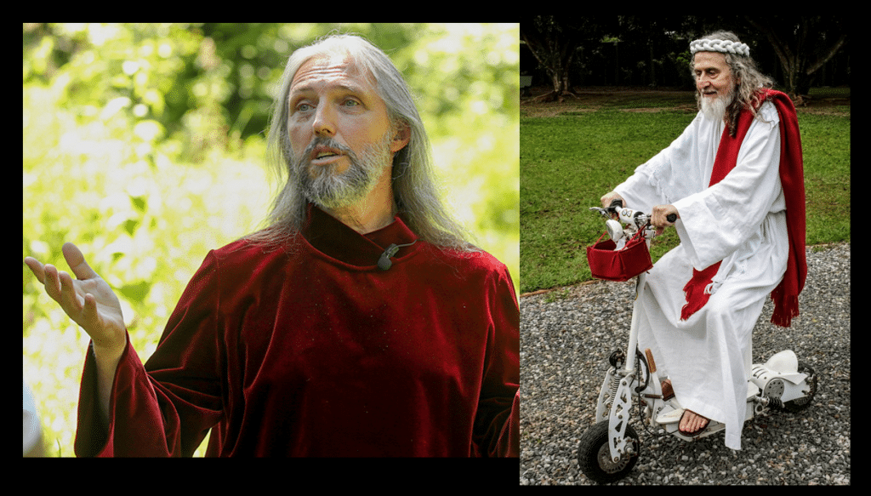Two of the latest clowns who claim to be Jesus Christ (Sergey Torop – Left, Alvaro Theiss – Right)
Anyone who knows their Bible would never be deceived by such men, because Christ’s return will follow the protocol, laid out in the Holy Writ. Biblical ignorance leads to rife deception and cult leaders’ prey on our disregard for God’s Word. Horace Greeley once said, “It is impossible to enslave, mentally or socially, a Bible reading people. The principles of the Bible are the groundwork of human freedom.“ Sadly, the popularity of cult leaders and false Christ’s in our day and age, is purely a reflection of our biblical ignorance.

3. Many shall go to and fro (Daniel 12:4)
Up until the late 19th century, the light two-person horse and buggy was the main mode of transport. In 1885 the first car was invented by Karl Benz. In 2020, there were 287 million cars in the United States alone. The minor prophet Nahum, prophesied the modern-day freeway, stating:

“The chariots shall rage in the streets, they shall justle one against another in the broad ways: They shall seem like torches, They shall run like the lightnings.”
Nahum 2:4

“The chariots shall rage in the streets, they shall justle one against another in the broad ways: They shall seem like torches, They shall run like the lightnings.”
Nahum 2:4
The Wright brothers invented the world’s first motor operated airplane on Dec 17th, 1903. Modern airplanes are inferred in the Bible, “Who are these that fly as a cloud, And as the doves to their windows?” (Isa 60:8). Today there are 5000 airlines in the world, with approximately 8000 jets flying commercially around the globe on any given day. Many do ‘go to and fro’ in these last days, as the Book of Daniel predicted thousands of years ago.
Commercial jets are causing traffic jams at 30,000ft

4. The sign of the fig tree (Matthew 24:32)
The main sign of Christ’s return is the formation of Israel as a nation. Israel is symbolized as a fig tree in the books of Jeremiah, Habakkuk, Joel and Hosea. Following their rejection of His son, God promised to restore Israel as a nation with an outstretched arm and gather them out of the countries into which they were scattered (Eze 20:33-24). This was fulfilled, by the fig tree blossoming on May 14th, 1948. Jesus said, the same generation that sees this fig tree blossom will also see His return (Matt 24:32).
The question then becomes, how long is a generation? If it’s a century (see Gen 15:12-16), then Christ will return no later than 2048. Israel has certainly blossomed as a nation since its founding. It’s $100 Billion economy is larger than all its neighboring countries combined. It has the highest standard of living in the middle east and is a world leader in the invention of new technologies. Since Mark Twain visited Israel in 1867, describing it as a “hopeless, dreary and heart-broken land,” God’s blessing has once again returned to the land. Many realize the Balfour declaration paved the way for Israel to become a nation, yet few consider the prophetic implications of the leadership of British Field Marshal Edmund Allenby.
The fig tree of Israel is blossoming before our very eyes.

World War I ended at 11am on November 11th, 1918. This was the 11th hour, of the 1World War I ended at 11am on November 11th, 1918. This was the 11th hour, of the 11th day of the 11th month, just 11 months after Field Marshal Allenby entered Jerusalem on December 11th, 1917. It was at that time, he made Palestine a homeland for the Jews. God was sounding the alarm bell over 100 years ago, that the 11th hour was upon us, one hour prior to His midnight return (Mat 25:5-6) bell over 100 years ago, that the 11th hour was upon us, one hour prior to His midnight return (Mat 25:5-6).
The number eleven can symbolize, disorder, chaos or judgment. It’s used 24 times in the Bible. If it was the 11th hour (over a century ago), how close are we to Christ’s return today? Christ warned in the parable of the foolish virgins (Mat 25:1-13), that He would return at the ‘midnight hour.’ Midnight is soon to strike for all of us, are you ready? I also believe this 11th hour typology, symbolizes God judging the present world system, putting it on notice, that His Millennial kingdom is soon to appear on earth.

5. The increase in the number and diversity of earthquakes (Luke 21:11)
Every year, there are some 50,000 detectable seismic or micro-seismic disturbances around the world. Seismology emerged as a science only in the mid-19th century. Seismographs were invented in 1853 and made available then to record quakes. The term seismology was introduced by Robert Mallet. He proposed a seismic map of the world and compiled a catalogue of 6,831 major shocks from the year 1606 BC to his time.

The increase in frequency and diversity of earthquakes have been meteoric since records began. In the 14th century there were 157 major earthquakes, in the 15th century 174 major earthquakes, in the 16th century 253 major earthquakes, in the 17th century 278 major earthquakes, in the 18th century 640 major earthquakes, in the 19th century 2,119 major earthquakes and finally, in the 20th century there were in excess of 900,000 earthquakes! This is equivalent to one earthquake every hour!
The increase in frequency and diversity of earthquakes have been meteoric since records began. In the 14th century there were 157 major earthquakes, in the 15th century 174 major earthquakes, in the 16th century 253 major earthquakes, in the 17th century 278 major earthquakes, in the 18th century 640 major earthquakes, in the 19th century 2,119 major earthquakes and finally, in the 20th century there were in excess of 900,000 earthquakes! This is equivalent to one earthquake every hour!

From the World Almanac comes another set of facts: there were only 6 earthquakes of strength between 1800 to 1896. But in each decade from 1897, until 1947, there were either 2 or 3, and in the decade from 1947 to 1956, there were 7. From 1957 to 1966, there were 17. Time magazine’s front cover for its Sept. 1, 1975, issue was a split earth with this inscription: “FORECAST: EARTHQUAKE.”
Since the formation of Israel on May 14th, 1948, there has been a relative explosion of earthquakes worldwide. As soon as ‘the’ sign of Christ’s return hit the timeline (i.e., the formation of Israel), earthquakes have been on the increase ever since. Since the year 2000 there have been 1433 earthquakes recorded worldwide, in excess of five, on the Richter scale, confirming that major earthquakes are also on the rise.

6. Apostasy of the church (Revelation 3:16)
The church has compromised in recent years and God is reshuffling the deck. Key leaders are stepping down and new leaders are rising up. The Book of Revelation warns the church of this age (Laodicea-Rev 3:14-22) would become ‘lukewarm’ and most assuredly this has come to pass right before our eyes. America is in its darkest hour, meanwhile the church is experiencing an untimely identity crisis. Our tepid attitude stems from a position of economic abundance, which is now under threat. Our spiritual apathy, causes Jesus to gag, spewing us out of His mouth! (Rev 3:16). If that’s not a wake-up call, I don’t know what is.
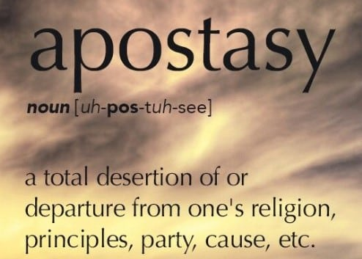
This Apostasy is all part of a dark spiritual agenda by seducing spirits, “Now the Spirit speaketh expressly, that in the latter times some shall depart from the faith, giving heed to seducing spirits, and doctrines of devils” (1st Tim 4:1). Several of the more prevalent false cults arose from within the church walls, including, Jehovah’s Witnesses, Mormonism, Christian Scientist’s, etc. These cults have forged ungodly doctrines, ‘seeking after their own lusts,’ having ‘itching ears,’ and turning away from the truth, they once knew, unto fables (2 Tim 3:1-5).
Men and women such as Charles Taze Russell (1852-1916), Joseph Smith (1805-1844), Mary Baker Eddy (1821-1910) and Ellen G. White (1827-1915), all told fables, and in the process, founded new religions, leading millions astray to damnation. Each one of them will give an account to God for their heresies.
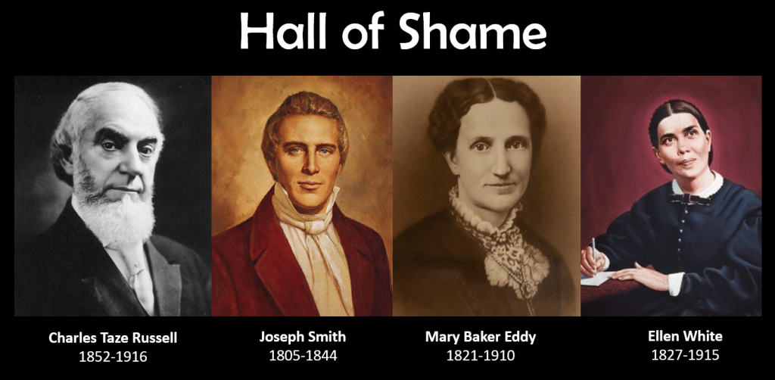

7. Wars and rumors of wars (Matthew 24:6)
Someone once described ‘peace’ as, ‘that brief time in history when man stops to reload.’ Warfare is a long-held tradition of man. Consider there were 21 world skirmishes in the 18th century, rising to 53 wars in the 19th century, leading to 35 larger worldwide conflicts in the 20th century. Not far into the 21st century we are on the verge of nuclear war. The cause for all these conflicts ranges from contention over natural resources, to the wickedly devised plots of the elite, who typically fund both sides of a conflict in order to amass wealth. Their coffers will be filled regardless, profiting from either outcome. History bears witness to the countless innocents killed by despots, desirous of power at all costs.

The University of Hawaii tallied the genocide of 151 million, by fifteen rogue governmental regimes in the 20th century alone! These rogue leaders had a communistic ideology by and large. This is why communism is so dangerous, it either ends in war or a stay in the gulag.
The University of Hawaii tallied the genocide of 151 million, by fifteen rogue governmental regimes in the 20th century alone! These rogue leaders had a communistic ideology by and large. This is why communism is so dangerous, it either ends in war or a stay in the gulag.
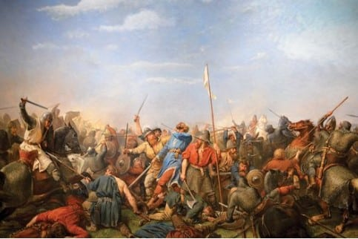‘Peace’ that brief time in history when man stops to reload.
History has proven, not all governments can be trusted. America is unique with three branches of government, comprising intrinsic checks and balances, to curtail the rise of tyranny. With rising inflation, limited natural resources and loss of value to the dollar, world leaders struggle to find a solution to the problems which beset mankind, on a universal scale. The Antichrist will come as a ‘wolf in sheep’s clothing,’ offering solutions, which are appealing on the surface. World leaders are now ripe to accept such a wolf, not realizing the wolf will later ensnare the entire world.
One of the “architects” of the European Union, Paul Henri Spaak (the Belgian Prime Minister at the time) said, “We do not want another committee. What we want is a man…to lift us out of the economic morass into which we are sinking. Send us such a man, and be he god or devil, we will receive him.” Just so you know Paul, the devil has someone waiting in the wings for you (Jn 17:12, 2 Thess 2:3).
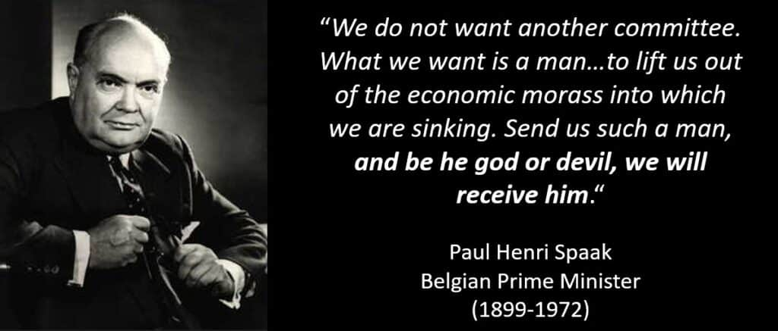

8. The corruption of the world through lust
(2 Peter 1:4; Revelation 19:2)
Since the beginning of the seed war (Gen 3:15), Satan has sought to corrupt all things. His original intention was to prevent the seed of the woman from giving birth to the Messiah. By causing Cain to murder his twin brother Abel in the first generation, he probably thought he’d achieved that aim. But God preserved the lineage of the Messiah despite various incursions by fallen angels attempting to pollute the blood line of Christ (Gen 6:1-4). Since the successful birth of the Messiah, Satan carries on corrupting all things, whether food, DNA, morals, the environment, political parties, geopolitics, the minds of the youth, or babies in the womb. Satan has an insatiable blood lust, seeking to steal, kill and destroy at every opportunity (Jn 10:10).
Satan commenced a seed war in the Book of Genesis
Did you know that when farmers save seed for the coming year, it’s now considered patent infringement? For millennia, farmers saved a batch of seed to plant in the following season, but when Monsanto (GMO world leader), patented seeds which would resist their own herbicide, the supreme court allied with them, claiming farmers were ‘in breach of patent’ for storing seeds, as they’d done for Millennia. Trouble is Monsanto’s modified seed doesn’t perpetuate and cannot be stored. Hence farmers have to keep purchasing these GMO seeds from suppliers to survive. Man, unfairly ousted God’s system of ‘seed, time and harvest,’ in a Supreme Court ruling. Life giving seeds which perpetuate from year to year, are no longer accessible because of Monsanto’s victorious lawsuit (circa. 2014).
Because of these genetically modified crops, they are more expensive for farmers to manage, and dangerous to the animals and humans who consume them. Farmer suicides are skyrocketing as a result. Satan did a number on the farmers, and your food supply too.

9. The return of the days of Noah (Luke 17:26)
Although the ‘days of Noah’ resulted in the destruction of the human race, save Noah and his family, there are some stark aspects of that time frame which have been overlooked. The days of Noah were clearly marked by moral degradation and increased violence, in tandem with rising population, to the point where God saw the wickedness of man, and every imagination of his heart being evil, continually. As a consequence, God was grieved and regretted He ever made man (Gen 6:5). However, the ‘evil’ spoken of in this passage, also included an incursion of Watcher angels, outlined in Genesis 6:1-4. This is also well documented in historical texts such as, the Book of Enoch, the Book of Jasher, the Book of Giants and Book of Jubilees.
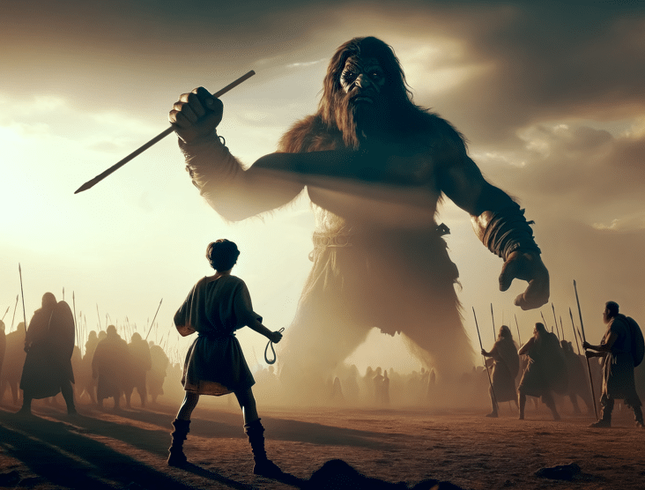Will Giants one day return to the earth?
For decades, seminaries falsely taught the ‘sons of God’ were the godly descendants of Seth, intermarrying with the wicked daughters of Cain. The sons of God (Heb: Banah Elohim) are mentioned six times in the Old Testament. Never once does this term refer to man, but angels exclusively. These Watcher angels forcibly, ‘took wives’ resulting in a half human-half angel hybrid, which populated the entire earth prior to Noah’s flood and also, ‘after that’ (Gen 6:4). These Giants, were the direct progeny of this angelic incursion. Subsequent progeny resulting from Giants were called Rephaim in contrast to the first generation, who were called Nephilim (fallen ones).
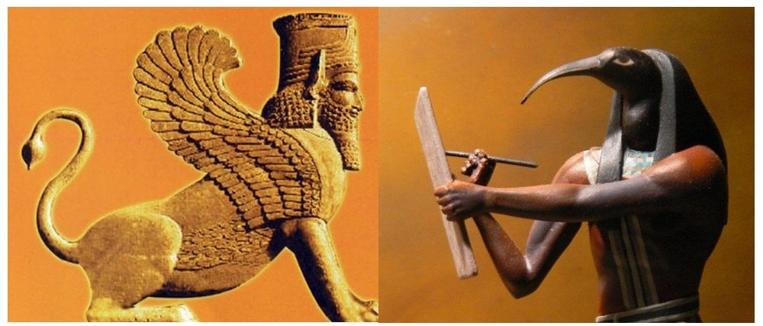These creepy depictions of animal-human hybrids adorn the interior walls of temples throughout Assyria, Babylon, Chaldea, Egypt, Persia etc. What if these hybrids reappeared in the near future?
From Abraham thru David (14 generations), Giants were encountered, in the precise vicinity where God promised land to Abraham (i.e., the Levant). The concept of gene tampering is nothing new, it occurred thousands of years ago, and many people struggle to believe this. The bizarre images (of half human-half animal hybrids) which adorn the interior of the pyramids of Egypt (save the Great Pyramid), depict evidence of DNA tampering, during this unique time frame.
Greek mythology also eulogizes these animal-human hybrids, better known as, chimeras. Scholars portend these fallen ‘watcher angels’ who descended upon Mount Hermon in the days of Jared, were solely responsible for developing human-animal hybrids, which incidentally, are clandestinely being grown in laboratories around the globe today, by private corporations, governments and the military industrial complex.

Scientists often advertise DNA modification as a benefit to mankind, but few realize that once a modification occurs in the genome, it CANNOT be reversed.
Gene manipulation is dangerous because of its permanency.
Much of our human DNA shares commonality with other species, which offers a blueprint for sharing the gene structure. This makes human-animal hybrids much easier to produce. In the near future, humans could be enhanced with unique features which only animals enjoy. Ever thought of modifying your eyesight to that of an eagle, or having the hearing capability of a dog? In the not-too-distant future, ‘enhancements’ could be made available to attain ‘superpowers’ borrowed from the animal kingdom. In addition, the CRISPER-Cas 9 genome editing capability, allows scientists to chop off segments of undesirable DNA, in order to optimize the human species or eradicate genetic diseases.
Some scientists tout their ability to cure terminal disease, utilizing this method, claiming it as a revolutionary breakthrough in evolutionary science. Designer babies could also be on the horizon by altering the undesirable components of its DNA, prior to its birth. This modern gene tampering is nothing new, merely a repeat of Satan’s plot (Gen 6:1-4), to corrupt mankind, created in God’s image. Each time man enhances his DNA, or splices it with genes from the animal kingdom, the purity of DNA is lost, and man’s progeny will be forever altered. According to investigative researcher Billy Crone, it only takes an alteration of one percent, of the genome, to no longer qualify as human. This is most disturbing because redemption through Christ is only attainable for ‘humans’ created in God’s image, not the image of technocracy.
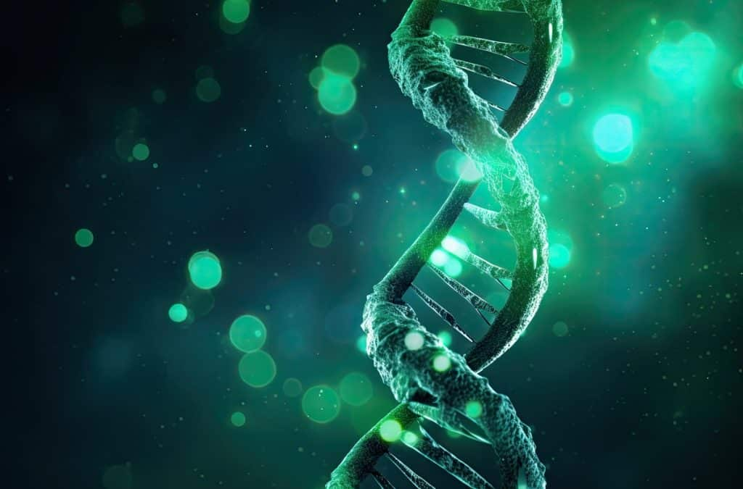Could the MARK OF THE BEAST, literally include animal DNA?
The Pandora’s box of gene manipulation technology, which was practiced in times of antiquity, has been reopened, with lasting and pernicious consequences, that have yet been fully realized. Whatever actions these scientists undertake, it is irreversible. This explains why those who take the MARK OF THE BEAST (Rev 13:16-17), will be forever damned because by doing so, they will no longer be ‘human.’ I believe the essence of the MARK OF THE ‘BEAST’ is hidden in plain sight, i.e. it will include animal DNA of some kind and corrupt man’s image, made in the likeness of God.

10. Great and fearful sights and great signs in the heavens (Luke 21:11)
Has anyone seen a UFO lately? Sightings of UFO’s are definitely on the increase and these visitors will soon become part of a global deception. UFO’s (or UAP’s -Unidentified Arial Phenomenon), will play a major part in the end-time deception of mankind. When the church is removed from the earth, the ‘restrainer’ will no longer be able to hold back Satan’s deceptive agenda (2 Thess 2:6-7). As L.A. Marzulli likes to say, ‘when we go up, they show up!” I firmly believe that aliens will claim to be progenitors of the human race and spin the evacuation of the church for their own advantage. The notion that aliens spawned life on earth is known as ‘Panspermia.’ UFO’s have been appearing in the skies from the beginning of time because the second heaven is Satan’s domain (Eph 2:2). Full disclosure of UFO’s have even been promised by our government in recent years, with military personnel sharing their encounters on news networks. Something is afoot.
What is about to be revealed will cause the greatest deception in the history of mankind and it’s only because of man’s rejection of God as creator of all things, will God allow such ‘strong delusion‘ to take place (2nd Thessalonians 2:10-12).
The false premise that aliens seeded the human race has been broadcast on prime-time by the History Channel, in a program entitled, ‘Ancient Aliens’ which has now run for 19 consecutive seasons.
Men look to the stars for their origins but UFO’s could be the harbingers of deceptive Panspermia
The national UFO Reporting Center estimates 450,000 abductions per year, with talk of molestation in a number of male and female abductees. This is most disturbing to say the least. Christ made an intriguing remark concerning the Days of Noah, saying, ‘they were given into marriage” (Lk 17:27). The question becomes, who are ‘they?’ We know that intercourse between angels and women, was a unique marker leading up to, the diabolical days of Noah but is this being repeated today, in the form of alien abduction?
Is Satan trying to recreate a hybrid race of his own, ready to be presented to the world at a time of his choosing? We can only speculate as to the authenticity of such close encounters of the third kind, although the premise that aliens are about to make ‘open-contact’ with mankind, is gaining traction through, movies, entertainment and even the news media. Satan, is no doubt subliminally, preparing the world for this ‘coming great deception’ and many will fall for it.

11. For the powers of the heavens will be shaken
(Luke 21:26)
Prior to the 20th century mankind did not have the capability of destroying itself. However, today, a single Polaris submarine has a greater destructive capacity than all the munitions used in World War II. Speaking of such destruction, Dr. Hachiya, a famous scientist who lived in Hiroshima, said, “A ten-megaton atomic bomb would exterminate all but the most deeply living things within a radius of five miles. Blast casualties would be severe up to ten miles.” Right now, all the nations combined possess 13,355 nuclear weapons, which are preemptively targeted upon the major cities of the world.
The ‘powers of the heavens’ will indeed be ‘shaken’ during the tribulation period as the arsenal of nuclear warheads will inevitably be unleashed. Interestingly, the word ‘heavens’ in this passage (Lk 21:26) is the Greek word, ouranos (οὐρανός), which is the root word for Uranium. The heavens will no doubt be shaken, by the dense silvery-grey chemical element used to fuel nuclear reactors and warheads, namely Uranium.
When the false prophet causes fire to come down from heaven (Rev 13:13), is this fire from a nuclear warhead? Today the kings of the east are rising (Rev 16:12). China and Russia are currently amassing a vast array of nuclear warheads, as America downgrades its military and nuclear prowess. These are dangerous times indeed.
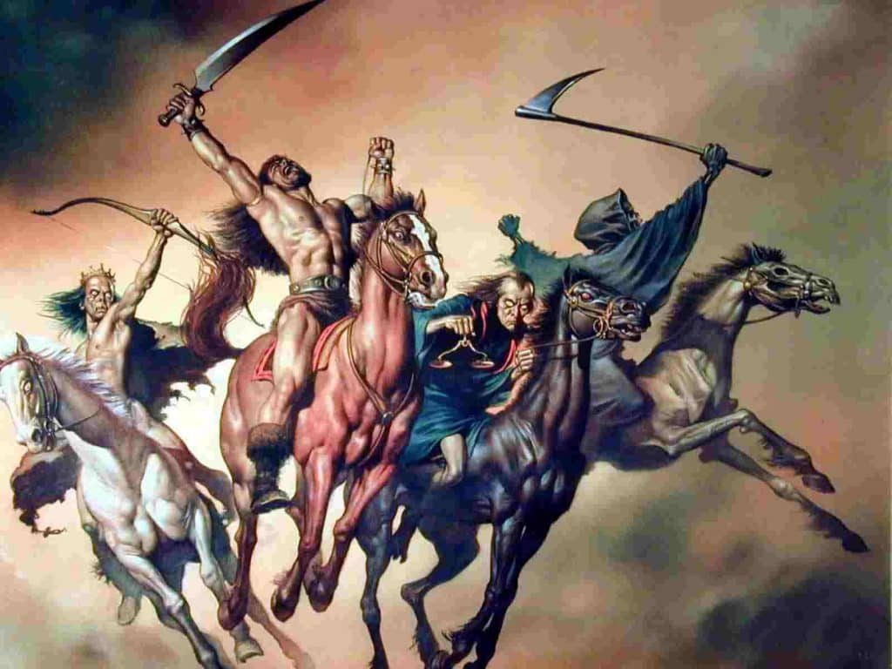The Four Horsemen of the Apocalypse (Rev 6:2)

12. The rise of Pestilence (Matthew 24:7)
Pestilence is ‘any deadly infectious malady.’ In the bible, the triumvirate of ‘sword, famine and pestilence,’ were used as tools of judgment by God, toward Israel for their many transgressions. The death of 70,000 Israelite’s after David’s census is an example of such severity of judgment (2nd Sam 24:13). With the recent COVID-19 pandemic, many are aware of the social impact of pestilence on a worldwide scale.
With a survival rate of 99.91%, the outbreak of ‘COVID-19’ is a far cry from the ‘Black Death’ (or Bubonic Plague) which ravaged Europe in the 14th century, killing 43 million! This was equivalent to more than 1/3rd of the population of Europe, at the time. Some cities were entirely depopulated by the plague such as Bristol, England. Half a million died in Venice, Italy within a two week period, due to ships containing rats which had infected plague carrying fleas on them.
To put COVID into perspective, the Spanish flu epidemic of 1918, killed 50 million people, a staggering 1% of the world population at the time. More succumbed to the Spanish Flu, than died from the four-year conflict of World War I (1914-1918). The long term socioeconomic impact of COVID however, could prove far more deadly than the disease itself, leading to mass food shortages for the third world particularly.
Is COVID a one off pandemic or the precursor to something more sinister?
In sharp contrast, COVID-19’s worldwide death toll of 6.3 million scarcely qualifies for the designation of a ‘pandemic,’ considering this represents less than 0.08% of the world’s current population. In addition, the number of patients who succumbed to influenza were significantly reduced during the pandemic, and in some instances, were categorized as COVID deaths instead, for financially motivated reasons. This led many to believe the actual death toll of COVID to be greatly exaggerated by the media and certainly fewer than the official number of 6.3 million. If anyone listened to the media during the pandemic, you’d be convinced that pretty much everyone was dying of COVID.
Nevertheless, pandemics will continue unabated, until Christ returns. The availability of Sarin gas, nerve agents, anthrax etc. by rogue governments is too dire to consider. In the past, plagues were never created by a human agency. In the modern era, deadly bacteria, germs, and viruses can be created in private or government sponsored laboratories. Biological weapons have long been created for the purposes of war but never for use on the general population. At this juncture, western nations claim China deliberately released COVID-19 on it’s population, eventually spreading around the globe. Only time will tell if this is true. If these biological weapons get into the wrong hands, the result could be catastrophic and far more deadly than the recent pandemic.
Are there other signs which could’ve been included? Yes. The Russian Confederacy, Nanotechnology, Artificial Intelligence, the rise of the New World Order, the saturation of the gospel in all nations, so on and so forth.
There are many signposts pointing to Christ’s return. The question is, are you ready for His return?
Retrieved September 28, 2026, from 12 Signs of Christ’s Return - Carl Joseph Ministries

